[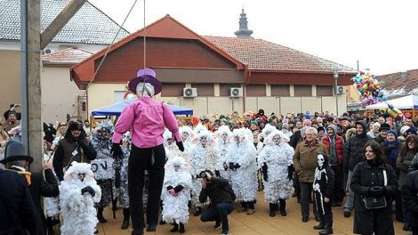](http://static05.emedjimurje.hr/uploads/2016/01/16/prelog-fasnjak_519059.jpg)